

REACT JS PROJECT REPORT ON
TITLE OF THE PROJECT

Submitted by
Hephzibah.J
24BIT115

Under the Guidance of
ARAVIND
Technical Trainer
Technical Department, KG College of Arts and Science

Academic Year: 2025 – 2026
APRIL 2026

DECLARATION
I hereby declare that the project entitled “Payroll Management System” submitted in partial fulfillment of the requirements for the course [React js] is a record of my original work carried out under the guidance of [Aravind], Technical Trainer, Technical Department, KG College of Arts and Science.
I further declare that this project has not been submitted previously, either in part or in full, for the award of any degree, diploma, or other similar title, at this or any other institution.
I have acknowledged all sources of information used in this project wherever applicable.

April 2026
Coimbatore

Hephzibah.J
(Your Name)

CERTIFICATE
This is to certify that the project entitled “Payroll Management System” is a bona fide work carried out by [Hephzibah.J] [II-B/2024], [B.Sc Information Technology], KG College of Arts & Science, in partial fulfillment of the requirements for the course [React Js].
This project has been completed under my supervision and guidance during the academic period April 2026.

Place:
Date:

Submitted for the Viva-Voce Examination held on __________________________________

Guide: Head of the Department
(Technical Trainer, KGCAS) (Technical Head, KGCAS)

______________________ _______________________

TABLE OF CONTENTS
S. No. | Topics | Page. No.
1 | Introduction
1.1 | Background of the Study
1.2 | Problem Statement
1.3 | Objectives of the Project
1.4 | Purpose and Significance
1.5 | Scope and Limitations
1.6 | Methodology Overview
2 | System Analysis
2.1 | Existing System
2.2 | Drawbacks of the Existing System
2.3 | Proposed System
2.4 | Features of the Proposed System
2.5 | Feasibility Study
2.6 | Requirement Analysis
3 | System Design
3.1 | System Architecture
3.2 | Use Case Diagram
3.3 | Data Flow Diagram (DFD)
3.4 | Entity Relationship Diagram (ERD)
3.5 | User Interface Design
4 | System Implementation
4.1 | Development Tools
4.2 | Module Description
4.3 | Algorithms
4.4 | System Integration
4.5 | Security and Validation
5 | System Testing
5.1 | Testing Methodology
5.2 | Test Cases
5.3 | Error Handling
5.4 | Performance
6 | Input and Output Screens
6.1 | System Outputs
6.2 | Discussion
6.3 | Comparison
6.4 | User Feedback
7 | Conclusion and Future Enhancement
7.1 | Summary
7.2 | Limitations
7.3 | Future Scope
8 | References
Appendices
- Source Code Snippets
- Screenshots of Web Pages

ABSTRACT
The Smart Payroll Management System is a web-based application designed to automate and manage employee salary processing efficiently. It helps organizations calculate salaries, deductions, and generate payslips accurately.
The system is developed using HTML, CSS, JavaScript (and React if you used it). It reduces manual errors and saves time by automating payroll calculations.
The application allows users to:
- Add employee details
- Calculate salary automatically
- Generate payslips
- View payroll records
This project demonstrates how web technologies can simplify payroll operations and improve accuracy, transparency, and efficiency in salary management.

Chapter 1: Introduction
  - Background of the Study
In recent years, digital technology has transformed how organizations manage their operations, especially payroll management. Payroll involves calculating employee salaries, deductions, and generating payslips, which was traditionally done manually or using spreadsheets, leading to errors and inefficiency. Manual processing is time-consuming and can cause inaccuracies in salary calculations, affecting both organizations and employees. To overcome these issues, automated systems are introduced to simplify payroll tasks. The Smart Payroll Management System is a web-based solution developed using HTML, CSS, and JavaScript that helps in calculating salaries accurately and efficiently. It reduces human errors, saves time, and improves the overall payroll process through a simple and user-friendly interface.
  - Problem Statement
Payroll management in many organizations is still carried out using manual methods or basic tools, which leads to several challenges such as calculation errors, time consumption, and difficulty in maintaining records. Mistakes in salary computation, tax deductions, or employee data can result in financial issues and dissatisfaction among employees. Additionally, manual systems lack automation, making it hard to manage payroll efficiently as the number of employees increases. There is a need for a reliable and user-friendly system that can automate payroll processes, reduce errors, and ensure accurate and timely salary management.
  - Objectives of the Project
- To develop a Smart Payroll Management System using web technologies
- To automate employee salary calculations
- To reduce manual errors in payroll processing
- To generate accurate payslips quickly

  - Purpose and Significance of the Study
The main purpose of this project is to develop a simple and efficient system for managing employee payroll digitally. It helps in automating salary calculations, reducing manual work, and minimizing errors. The system is significant as it improves accuracy, saves time, and makes payroll processing easier for organizations. It also provides a user-friendly interface, making it accessible for users without technical knowledge.
1.5 Scope and Limitations
Scope:
The scope of this project includes managing employee salary details and performing automatic salary calculations efficiently. It allows users to generate payslips quickly and provides a simple and user-friendly interface for easy operation. The system focuses on basic payroll functions and demonstrates how web technologies can be used to simplify salary management.
Limitations:
The system has certain limitations as it does not include database integration or user authentication features. It is limited to basic payroll operations and does not support advanced functionalities required for large-scale organizations. The system also stores data temporarily, making it less suitable for long-term record management.
  - Methodology Overview
The development of the Smart Payroll Management System follows a structured Software Development Life Cycle (SDLC) approach. The process begins with requirement analysis, where the system needs and functionalities are identified. This is followed by system design, where the structure and workflow of the application are planned. Next, the development phase involves coding the system using HTML, CSS, and JavaScript. After development, the system is tested to ensure all functions work correctly and without errors. Finally, the system is implemented and made ready for use, ensuring a smooth and efficient payroll management process.

Chapter 2: System Analysis
2.1 Existing System
In many organizations, payroll management is carried out using manual methods or basic tools such as spreadsheets. In this system, employee salary details, allowances, and deductions are entered and calculated manually, which requires more time and effort. These methods lack automation and depend heavily on human involvement, increasing the chances of errors in calculations and data handling. Additionally, maintaining records and updating employee information becomes difficult, especially as the number of employees increases. The existing system is not efficient, reliable, or scalable for modern organizational needs.
2.2 Drawbacks of the Existing System
. Time-consuming manual process
· High chances of calculation errors
· Difficult to maintain and update records
· Lack of automation and efficiency
· Not suitable for handling large data

2.3 Proposed System
The proposed Smart Payroll Management System is a web-based application designed to automate payroll processes and improve efficiency. It allows users to enter employee details, calculate salaries automatically, and generate payslips quickly and accurately. The system reduces manual effort and minimizes errors by using predefined logic for salary calculation. It provides a simple and user-friendly interface, making it easy for users to manage payroll tasks. This system is more reliable, faster, and suitable for modern organizational needs compared to the existing manual methods.

2.4 Features of the Proposed System
- Automatic salary calculation
- Easy entry of employee details
- Quick payslip generation
- User-friendly interface
- Reduces manual errors

2.5 Feasibility Study
Technical Feasibility:
The system uses simple web technologies like HTML, CSS, and JavaScript, making it easy to develop and run.
Economic Feasibility:
The project is low cost as it uses free tools and does not require expensive software.
Operational Feasibility:
The system is easy to use and does not require special training for users.

2.6 Requirement Analysis
Functional Requirements:
• Add and manage employee details
· Calculate salary automatically
· Generate and display payslips
· Validate user inputs

Non-Functional Requirements:
- Fast and efficient performance
- User-friendly interface
- Reliable and accurate output
- Easy to maintain and scalable

Chapter 3: System Design
3.1 Introduction
The Smart Payroll Management System follows a simple three-layer architecture consisting of the presentation layer, application layer, and data layer. The presentation layer handles user interaction through the interface, the application layer processes salary calculations and logic, and the data layer manages employee and payroll data. This structure ensures smooth operation and better organization of the system.
3.2 System Architecture
The system follows a three-layer architecture — Presentation Layer (Frontend), Application Logic Layer, and Data Layer.

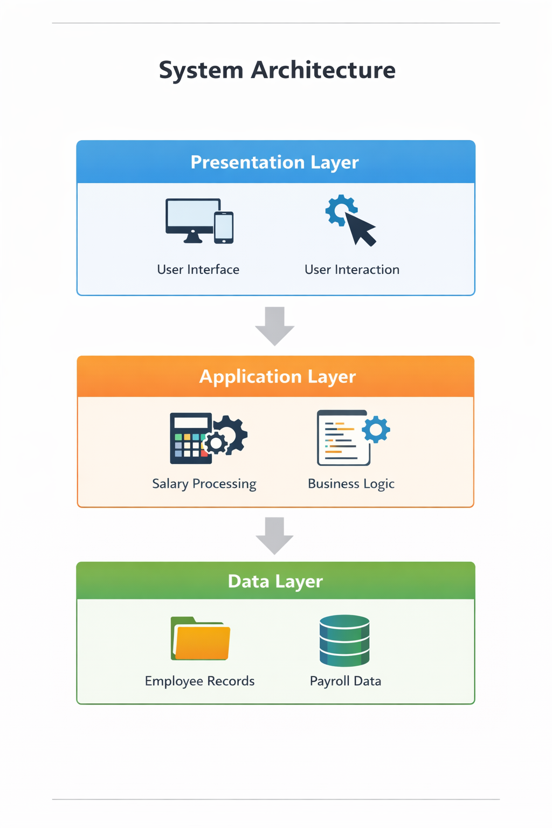
Description:
- The system architecture is divided into three layers: presentation, application, and data layer.
- The presentation layer handles user interaction through the interface.
- The application layer processes salary calculations, while the data layer stores employee and payroll details.

3.3 Use Case Diagram
1. What is a Use Case Diagram?
A Use Case Diagram is a visual representation that shows how users interact with a system. It identifies the actors (users) and the use cases (functions or actions) they can perform. It helps in understanding the functionality of the system and the relationship between users and system operations.
2. System Architecture
Actor | Description
Presentation Layer | Handles user interaction and displays employee details, salary, and payslip through the interface
Application Layer | Processes input data, performs salary calculations, and manages payroll logic
Data Layer | Stores employee information and payroll details using local storage or data files
- Identify the Main Use Cases
For User/Admin
- Add Employee Details
- View Employee Information
- Calculate Salary
- Generate Payslip
- View Salary Details
For Administrator
· Add Employee Details
· Update Employee Information
· Delete Employee Records
· Calculate and Manage Salaries
· Generate and View Payslips

4. Define Relationships
Symbol | Meaning
Association | Shows the interaction between actor and use case
<<include>> | Represents a compulsory function included in another use case
<<extend>> | Represents an optional or conditional function
Example:
“Calculate Salary” <<include>> “Generate Payslip”
“View Payslip” <<extend>> “Calculate Salary
5. Draw the Diagram (Structure Example)
Tools you can use:
- draw.io (free online)
- Lucidchart
- StarUML
- MS Visio
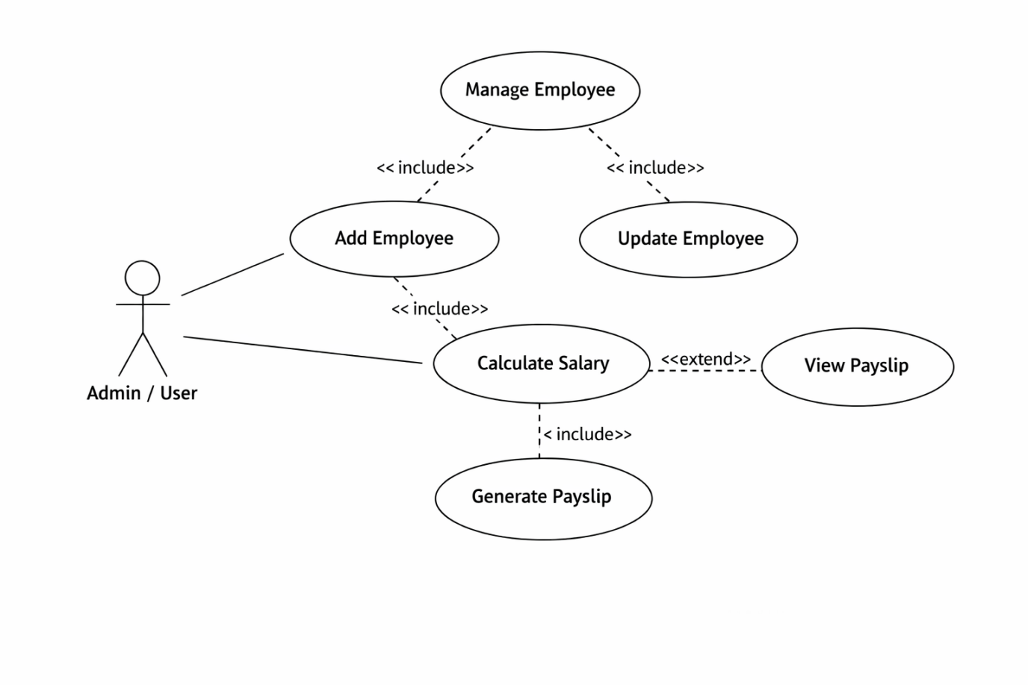

6. Example Explanation (Text Description)
Actors:
- Admin/User: The person who manages employee details and performs payroll operations.
Use Cases:
· Add Employee: Admin enters employee details into the system.
· Update Employee: Admin modifies existing employee information.
· Calculate Salary: System processes salary based on inputs.
· Generate Payslip: System creates payslip after salary calculation.
· View Payslip: Admin views salary details and results.

Relationships:
• “Calculate Salary” <<include>> “Generate Payslip”
· “View Payslip” <<extend>> “Calculate Salary”
· “Manage Employee” <<include>> “Add / Update Employee Details”

- Step-by-Step (Using draw.io)
• Go to https://app.diagrams.net
· Choose a blank diagram and name it “Use Case Diagram – Payroll System”
· Drag a stick figure to represent the actor (Admin/User)
· Draw ovals to represent use cases like Add Employee, Calculate Salary, Generate Payslip
· Draw a system boundary box and label it “Smart Payroll Management System”
· Connect actor and use cases using lines (association)
· Add relationships like <<include>> and <<extend>> between use cases
· Export the diagram as PNG/JPG and insert it into your document

3.4 Data Flow Diagram (DFD)
1. What is a Data Flow Diagram (DFD)?
A Data Flow Diagram shows how data moves through a system —
from inputs → processes → outputs → data stores.
It helps you visualize:
- Where the data comes from (source)
- What processes modify or use it
- Where it is stored
- Where it goes (destination)
2. DFD Symbols You’ll Use
Symbol | Meaning
Rectangle | Represents external entity (e.g., Admin/User)
Circle / Rounded Rectangle | Represents process (e.g., Calculate Salary)
Two Parallel Lines | Represents data store (e.g., Employee Data)
Arrow | Represents flow of data between components

3.4 Data Flow Diagram (DFD)

3. Levels of DFD
Level 0 — Context Diagram
Shows the overall payroll system and user interaction.
Level 1 — Decomposition
Shows main processes like employee input, salary calculation, and payslip generation.
Level 2 — Detailed Level
Shows detailed steps like allowances, deductions, and final salary.
- Steps to Create a DFD
Step 1: Identify External Entities
Admin/User, Payroll System
Step 2: Identify Main Processes
Enter Employee Details, Calculate Salary, Generate Payslip
Step 3: Identify Data Stores
Employee Data, Salary Data, Payslip Records
Step 4: Identify Data Flows
Employee Input, Salary Details, Payslip Output
5. DFD for Educational Website
Level 0: Context Diagram
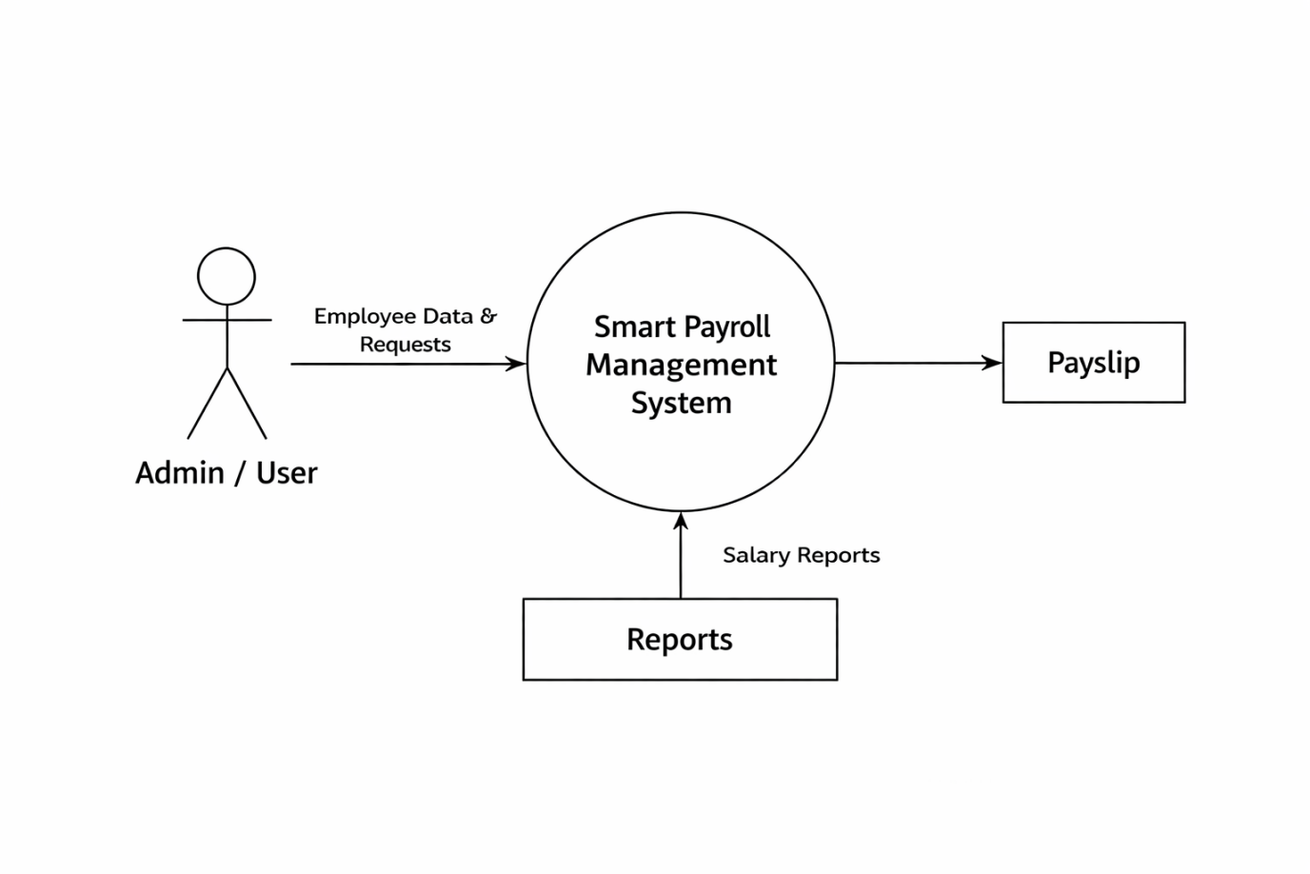
Explanation:
· It shows the entire Smart Payroll Management System as a single process interacting with the admin/user.
· It represents how employee data is given as input and payslip or salary output is generated.
Level 1: Detailed System View
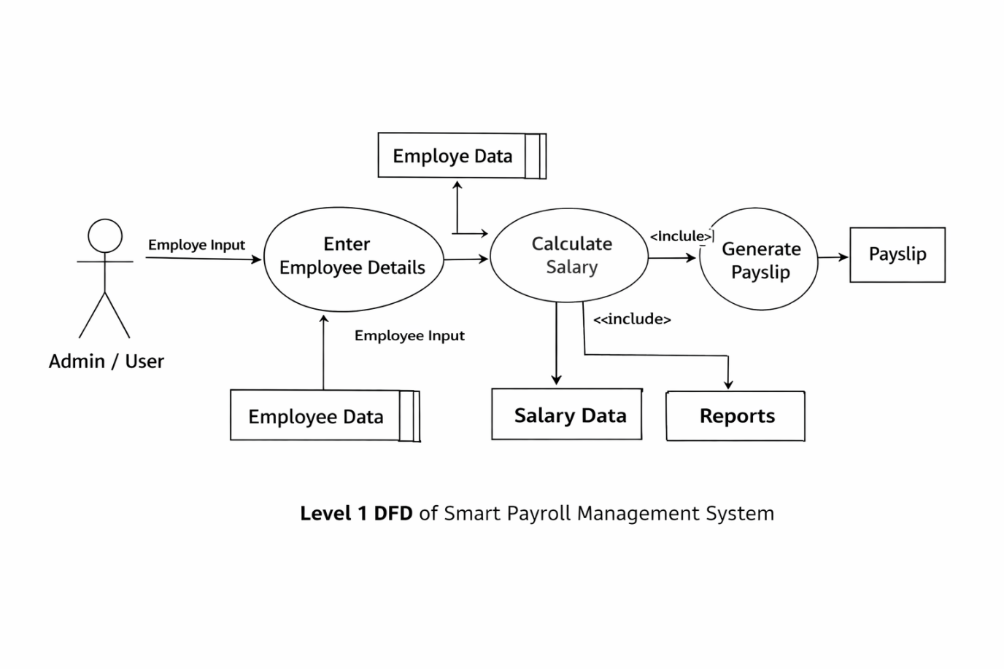
Explanation:
- Shows processes like employee input, salary calculation, and payslip generation
- User gives input and system processes it
- Data is stored in employee and salary data stores
- Output is generated as payslip and reports
Level 2: Quiz Process (Example Sub-process)

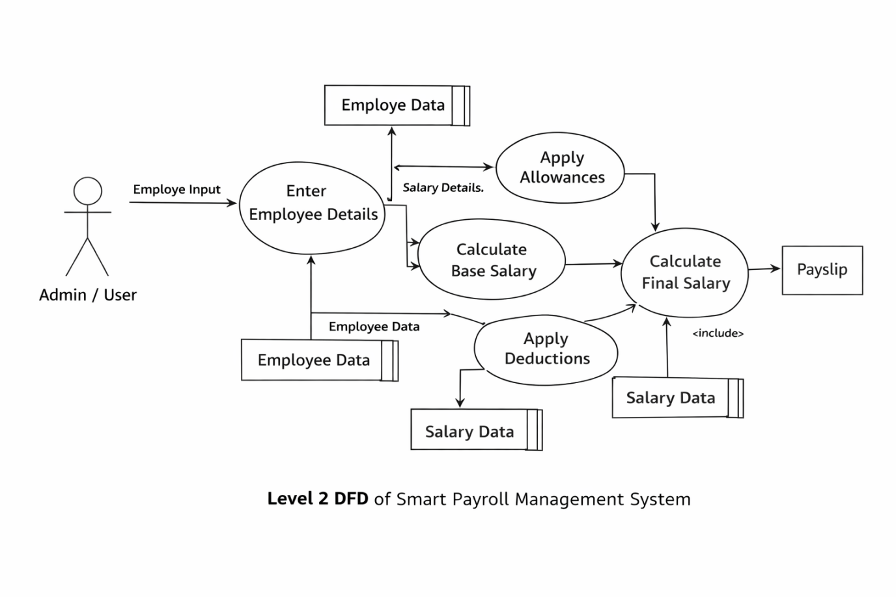

- Tools to Draw Your DFD
- draw.io (diagrams.net)
- Lucidchart
- Microsoft Visio
- StarUML
Steps (in draw.io):
· Identify external entities (Admin/User)
· Identify main processes (Salary Calculation, etc.)
· Identify data stores (Employee Data, Salary Data)
· Connect using arrows (data flow)

3.5 Entity Relationship Diagram (ERD)
An Entity Relationship Diagram (ERD) is used to represent the data structure of the Smart Payroll Management System. It shows the entities involved in the system and the relationships between them. The ERD helps in organizing employee and payroll data in a clear and structured way, making it easier to understand how data is stored and connected within the system.
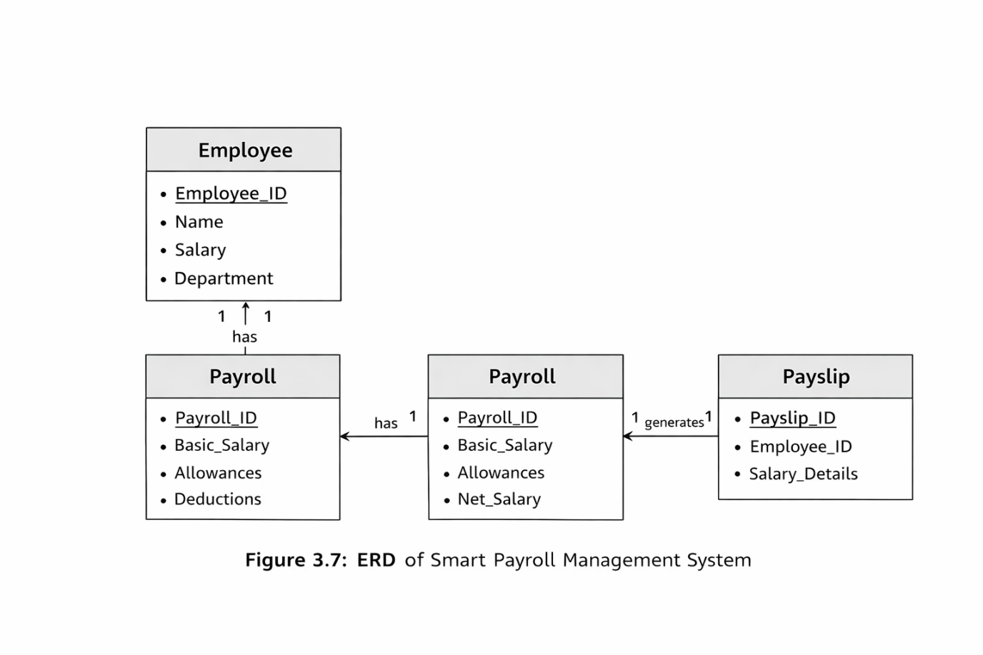

3.6 User Interface Design
The User Interface Design of the Smart Payroll Management System focuses on providing a simple and user-friendly experience for the users. The system includes different screens such as the employee details form, salary calculation page, and payslip display page. The interface is designed using HTML, CSS, and JavaScript to ensure clarity and ease of use. Users can easily enter employee data, view salary details, and generate payslips without difficulty. The design ensures smooth navigation and efficient interaction with the system.

Chapter 4: System Implementation
4.1 Introduction
The implementation phase involves developing the Smart Payroll Management System based on the designed structure. In this phase, the system is created using web technologies such as HTML, CSS, and JavaScript. The main goal is to convert the design into a working application that can perform payroll operations efficiently. This phase ensures that all modules like employee management, salary calculation, and payslip generation function correctly and provide accurate results.

4.2 Development Tools and Technologies
Tool / Technology | Purpose
HTML5 | Used to create the structure of the web pages
CSS3 / Bootstrap | Used to design and style the user interface
JavaScript (ES6) | Used to implement logic and salary calculations
Visual Studio Code | Used as the development environment
Browser (Chrome / Edge) | Used as the development environment
LocalStorage / JSON | Stores course and quiz data locally on the browser.
4.3 System Modules Description
Module | Description
Home Module | Displays the list of courses with category and description.
Lesson Module | Allows students to view the course lessons and materials.
Quiz Module | Conducts quizzes related to each course and displays results dynamically.
Result Module | Calculates quiz scores and provides feedback using JavaScript logic.
Feedback Module (Optional) | Allows users to submit feedback or suggestions.
Each module is interconnected through JavaScript functions, ensuring smooth navigation and state management within the website.
4.4 Implementation Details
The implementation follows a modular approach:
- Frontend Design:
HTML and CSS are used to create a simple and user-friendly interface.
- Dynamic Behavior:
JavaScript is used to perform salary calculations and display results dynamically.
- Event Handling:
User actions like button clicks and form submissions are handled using JavaScript event
- Data Management:
Data is stored using localStorage or variables for processing.
4.5 Algorithm / Logic of Core Function
Algorithm for Quiz Evaluation:
- Start
- Input employee salary details
- Add allowances to basic salary
- Subtract deductions from total
- Calculate net salary
- Display salary and generate payslip
- Stop

Algorithm for Dynamic Lesson Display:
- Start
- Load employee data from storage
- Loop through employee records
- Create elements to display data
- Display details on the screen
- Update data when user interacts
- Stop

4.6 Security and Validation
- Input validation is used to avoid incorrect or empty data entry
- Only valid employee details are processed for salary calculation
- Error messages are displayed for invalid inputs
- Data is handled securely within the system

4.7 Integration
Integration combines all modules of the Smart Payroll Management System into a single working system. Modules like employee details, salary calculation, and payslip generation are connected using JavaScript. The system ensures smooth data flow between modules, allowing accurate processing and display of results.

Chapter 5: System Testing
  - Introduction
System testing is an important phase in the development of the Smart Payroll Management System. It ensures that the system works correctly and meets all requirements. During this phase, different modules such as employee details, salary calculation, and payslip generation are tested to verify their functionality. The testing process helps to identify errors and ensures that the system provides accurate and reliable results.

  - Objectives of Testing
· To ensure all modules function correctly
· To identify and fix errors in the system
· To verify accurate salary calculation
· To check overall system performance

5.3 Types of Testing Performed
a) Unit Testing
Each module like salary calculation and data display is tested individually.
b) Integration Testing
All modules are combined and tested to ensure smooth interaction.
c) System Testing
The complete system is tested to check overall functionality.
d) User Acceptance Testing (UAT)
The system is tested by users to ensure it meets requirements.
e) Cross-Browser and Device Testing
The system is tested on different browsers for compatibility.
5.4 Test Plan
Test ID | Module | Test Description | Type | Expected Output | Status
T01 | Employee | Enter employee details | Functional | Data stored correctly | Pass
T02 | Salary | Calculate salary | logic | Correct salary displayed | Pass
T03 | payslip | Generate payslip | output | Payslip displayed correctly | Pass
T04 | validation | Submit empty fields | validation | Error message shown | Pass
T05 | Navigation | Move between modules | Integration | Smooth navigation | Pass
5.5 Test Data and Execution
Sample employee data is used to test the system functions such as salary calculation and payslip generation. The inputs are provided, and the system processes the data to produce outputs. The results are then compared with expected outputs to ensure accuracy and correct functioning of the system.

5.6 Error Handling
. Displays error messages for invalid or empty inputs
· Prevents incorrect data from being processed
· Ensures smooth functioning without system crashes
5.7 Performance and Usability Testing
· System provides fast and accurate results
· Easy to use with simple interface
· Works smoothly across different devices and browsers

5.8 Results and Observations
The Smart Payroll Management System performed successfully during testing. All modules such as employee details entry, salary calculation, and payslip generation worked correctly. The system produced accurate results and responded quickly to user inputs. No major errors were found, and the overall performance of the system was efficient and reliable.

Chapter 6: Results and Discussion
6.1 Introduction
This chapter presents the results obtained from the Smart Payroll Management System after implementation and testing. It explains how the system performs in real-time and how effectively it meets the project objectives. The outputs generated by the system are analyzed to evaluate its accuracy, efficiency, and usability.

6.2 System Outputs
During execution, the system produced the following key results:

Employee Details Output
Displays employee information such as name, ID, and salary details.

Salary Calculation Output
Shows the calculated salary including allowances and deductions.

Payslip Output
Generates and displays the final payslip with net salary.

System Response Output
Provides quick and accurate results without delay.

6.3 Performance Analysis
· System responds quickly to user inputs
· Salary calculations are accurate
· Handles data efficiently without errors
· Works smoothly on different devices
6.4 User Feedback
· Users found the system easy to use
· Interface is simple and clear
· Provides quick and accurate results

Chapter 7: Conclusion and Future Enhancement
  - Conclusion
The Smart Payroll Management System was successfully developed to automate payroll operations. The system allows users to manage employee details, calculate salaries, and generate payslips efficiently. It reduces manual effort and errors while improving accuracy and speed. Overall, the project meets its objectives and demonstrates the effective use of web technologies in payroll management.
In addition, the system provides a simple and user-friendly interface that makes it easy for users to perform payroll tasks without technical difficulty. The project also highlights how digital solutions can improve organizational efficiency and can be further enhanced with advanced features in the future.

  - Limitations
· No database integration
· No user login or authentication
· Limited to basic payroll functions
· Not suitable for large-scale organizations
7.3 Future Enhancement
The project can be enhanced and scaled in several ways:
- Add database integration for data storage
- Implement user login and authentication
- Develop admin dashboard for management
- Enable report generation and analytics
- Add employee self-service features
- Improve user interface and design
- Deploy the system on cloud platform

Chapter 8: References
8.1 Books & Journals
· Web Technologies: HTML, CSS, JavaScript — Uttam K. Roy
· Learning Web Design — Jennifer Niederst Robbins
· Software Engineering — Ian Sommerville

8.2 Online Resources
· https://www.w3schools.com
· https://developer.mozilla.org
· https://www.geeksforgeeks.org
· https://javascript.info

8.3 Tools & Frameworks Used
· Editor: Visual Studio Code
· Languages: HTML, CSS, JavaScript
· Storage: LocalStorage / JSON
· Browser: Google Chrome / Microsoft Edge

Appendices
Appendix A – Source Code
Include your main source files:
- index.html — Homepage and structure.
- style.css — Styles and responsive layout.
- script.js — Core logic for lessons, quizzes, and interactivity.
(Attach or paste formatted source code snippets here — only essential parts, not full-length code, to maintain report readability.)
Appendix B – Screenshots of Web Pages
Attach labeled screenshots with captions:
- Figure 1.1: Homepage displaying available courses.
- Figure 1.2: Lesson Viewer interface.
- Figure 1.3: Quiz Page with active questions.
- Figure 1.4: Result Page showing user score and feedback.
- Figure 1.5: Responsive view on mobile devices.
(Ensure all figures are captioned and referenced in your text, e.g., “Refer to Figure 1.3”).
Appendix C – User Manual / Installation Guide
Steps to Run the Project:
- Download all project files (index.html, style.css, script.js).
- Place them in the same folder.
- Open index.html in any modern browser (Chrome, Firefox, Edge).
- Browse courses, read lessons, and attempt quizzes.
- Check your result displayed instantly on the page.
System Requirements:
- OS: Windows / macOS / Linux
- Browser: Latest Chrome or Firefox
- RAM: Minimum 2 GB
- Storage: 100 MB free

